Page 1
Capstone Project
Assignment 1

Course code: CSA1643
Course :Data mining and data warehousing
S.No: 25
Name : Vaibhav.K
Reg. No: 192211869
Slot : C
Title : Disease Outbreak Prediction Using Epidemiology Data for Blood Cancer via Data Warehousing
Assignment Release Date : 14/02/2024
Assignment Preliminary Stage ( Assignment 1 ) submission Date : 20/03/2024
Mentor Name : Dr. Vishnu priya
Mentor Phone number and Department :
8870368009 (Biotechnology Environment)

1.Preliminary Stage

1.1 Assignment Description :
The project focuses on utilizing epidemiological data and data warehousing techniques to predict disease outbreaks, specifically targeting lung cancer cases across various states in the US and examining cancer rates among different age groups. By integrating data from national cancer registries, public health databases, hospital records, and demographic surveys, the project aims to conduct comprehensive analysis and modeling to forecast potential outbreaks. Through this endeavor, the overarching goal is to enhance proactive healthcare management and resource allocation strategies.

The project will involve meticulous data collection, cleansing, and preprocessing to ensure data quality and consistency. Exploratory data analysis techniques will be employed to uncover spatial and temporal patterns in lung cancer incidence and identify correlations between risk factors and disease prevalence. Descriptive statistics, distribution plots, and correlation analysis will be utilized to elucidate relationships within the data, while visualization tools such as choropleth maps and heat maps will aid in presenting findings comprehensively. Ultimately, the project endeavors to contribute to the advancement of disease surveillance and control efforts, offering insights for targeted interventions and improved public health outcomes.
The assignment will involve a systematic and rigorous methodology, encompassing various stages from data collection to model development and validation. Special emphasis will be placed on data quality assurance, ensuring that the collected data is accurate, reliable, and representative of the target population. The project will adhere to ethical guidelines and data privacy regulations to safeguard the confidentiality and privacy of sensitive healthcare information. Additionally, the assignment will incorporate feedback and insights from domain experts to validate the predictive model and enhance its accuracy and reliability.

1.2 Assignment Work Distribution :
Project Scope Definition:

Define the scope and objectives of the project :

The project aims to utilize epidemiological data to predict lung cancer outbreaks across US states and assess cancer rates in different age groups, ultimately enhancing disease surveillance and control efforts.The scope of this project encompasses the development of a predictive model for blood cancer outbreaks using epidemiology data and data warehousing techniques. The primary objective is to create a comprehensive framework that can anticipate the occurrence of blood cancer outbreaks with precision, thereby enabling proactive intervention and resource allocation in health care systems. The project will focus on analyzing various factors contributing to blood cancer outbreaks, including demographic patterns, geographical distribution, temporal trends, genetic predispositions, and environmental influences.

Specific goals of analyzing :
Specific objectives include identifying geographical and demographic patterns in lung cancer incidence, correlating potential risk factors, and developing predictive models for outbreak forecasting.dentifying and characterizing the demographic patterns associated with blood cancer incidence, including age, gender, ethnicity, and socioeconomic status.Exploring the geographical distribution of blood cancer outbreaks to identify high-risk regions and hotspots for targeted interventions.Investigating the role of genetic predispositions and familial history in blood cancer outbreaks through genetic epidemiology studies.Assessing the impact of environmental factors such as air pollution, radiation exposure, chemical exposures, and lifestyle factors on blood cancer risk.Developing predictive models using machine learning algorithms, such as logistic regression, decision trees, random forests, and neural networks, to forecast blood cancer outbreaks.Evaluating the performance of predictive models using metrics such as accuracy, sensitivity, specificity, and area under the receiver operating characteristic curve (AUC-ROC).Validating the predictive models using cross-validation techniques to assess their generalizability and robustness across different populations and settings.Integrating the predictive models into decision support systems and public health surveillance platforms to provide real-time monitoring and early warning alerts for blood cancer outbreaks.

The objectives of the project include:

Collecting and aggregating epidemiology data related to blood cancer from diverse sources, including health care databases, research institutions, public health records, and epidemiological studies.Preprocessing and cleansing the collected data to ensure accuracy, completeness, and consistency for analysis.Developing advanced predictivemodels using data warehousing techniques to forecast blood cancer outbreaks.Conducting exploratory data analysis to uncover insights, detect patterns, and identify potential risk factors associated with blood cancer outbreaks.Understanding the geographical distribution and temporal trends of blood cancer incidence to facilitate targeted interventions and resource allocation.Investigating the impact of demographic factors, genetic predispositions, and environmental influences on blood cancer outbreaks.Validating the predictive models using rigorous evaluation metrics and cross-validation techniques to ensure reliability and accuracy.Integrating the predictive models into decision support systems for health care authorities to facilitate timely interventions and proactive management of blood cancer outbreaks.Collaborating with interdisciplinary teams comprising epidemiologists, data scientists, health care professionals, and software engineers to ensure a comprehensive and effective approach.Adhering to ethical guidelines and data privacy regulations to safeguard the confidentiality and privacy of sensitive health care information throughout the project.

Data Collection and Preparation:

Identify the Data Sources:

1. Health care Databases: Utilize electronic health records (EHRs) from hospitals and clinics to access patient information, diagnosis codes, treatment history, and laboratory results.
2. Cancer Registries:Access national and regional cancer registries to gather data on blood cancer incidence, including cancer type, stage, and demographic information.
3. Epidemiological Studies:Incorporate data from epidemiological studies focusing on blood cancer, including cohort studies, case-control studies, and population-based surveys.
4. Public Health Records: Access public health databases maintained by government agencies to gather information on disease surveillance, outbreaks, and public health interventions related to blood cancer.
5. Research Institutions: Collaborate with research institutions conducting studies on blood cancer epidemiology, genetics, and environmental factors to access relevant datasets.
6. Genetic Databases:Access genetic databases such as the National Center for Biotechnology Information (NCBI) and the Database of Genotypes and Phenotypes (dbGaP) to gather information on genetic predispositions and mutations associated with blood cancer.
7. Environmental Databases:Access environmental databases maintained by environmental protection agencies to gather information on air quality, water quality, radiation exposure, and chemical exposures potentially linked to blood cancer.

Develop a Data Collection Plan:

1. Define Data Variables: Identify key variables to collect, including demographic information (age, gender, ethnicity), clinical data (diagnosis, treatment), genetic information (genetic markers, mutations), and environmental factors (pollution levels, radiation exposure).
2. Data Collection Methods: Determine the methods for data collection, including direct extraction from electronic health records, surveys, interviews, and data mining techniques.
3. Data Collection Tools: Select appropriate data collection tools such as electronic data capture systems, survey instruments, and data extraction software.
4. Sampling Strategy:Define the sampling strategy, including the population to be studied, sample size calculation, and sampling techniques (random sampling, stratified sampling).
5. Data Collection Schedule: Establish a timeline for data collection activities, including start and end dates, data collection periods, and frequency of data updates.
6. Data Quality Assurance:Implement quality assurance measures to ensure data accuracy, completeness, and consistency, including data validation checks, double data entry, and regular audits.
7. Data Security and Privacy: Implement protocols to protect the security and privacy of sensitive health information, including data encryption, access controls, and compliance with data protection regulations.

Cleanse and Preprocess the Collected Data to Ensure Data Quality:

1. Data Cleaning:Identify and rectify errors, inconsistencies, and missing values in the collected data using techniques such as outlier detection, imputation methods, and data validation checks.
2. Standardization: Standardize data formats, units of measurement, and coding systems to ensure consistency and comparability across datasets.
3. Normalization: Normalize data distributions to improve model performance and interpretability, including log transformation, z-score normalization, and min-max scaling.
4. De-duplication: Identify and remove duplicate records or redundant information to ensure data integrity and accuracy.
5. Feature Engineering:Create new features or variables derived from existing data to capture additional information or improve predictive model performance.
6. Data Integration: Integrate data from multiple sources into a unified dataset, resolving any inconsistencies or conflicts between datasets.
7. Data Imputation: Impute missing values using appropriate techniques such as mean imputation, median imputation, or predictive modeling approaches to retain valuable information and minimize bias.

Consistency of the Project:

1. Project Management: Establish clear project goals, timelines, and milestones to ensure consistency and progress tracking throughout the project life cycle.
2. Documentation: Maintain comprehensive documentation of project activities, including data collection protocols, preprocessing steps, analysis methods, and model development processes.
3. Version Control: Implement version control systems to track changes and revisions to project artifacts, ensuring consistency and reproducibility of results.
4. Quality Assurance:Implement quality assurance processes to validate data integrity, model performance, and adherence to project objectives and standards.
5. Team Collaboration:Foster open communication and collaboration among team members, including regular meetings, progress updates, and knowledge sharing sessions.
6. Adherence to Standards: Ensure adherence to industry best practices, ethical guidelines, and regulatory requirements related to data collection, preprocessing, and analysis.
7. Continuous Improvement: Encourage continuous improvement and feedback loops to refine project processes, methodologies, and outcomes iteratively.

- Exploratory Data Analysis (EDA):

Conduct exploratory data analysis :

Exploratory data analysis will involve examining spatial and temporal trends in lung cancer incidence, as well as variations in cancer rates among different age groups.We will use a publicly available dataset (a CSV file) that contains information on the total rates and numbers of lung cancer cases in different states of the US, as well as the cancer rates of different age groups

- Data Summary:

Begin by summarizing the key characteristics of the dataset, including the number of observations, variables, and their types (numerical, categorical).Compute summary statistics such as mean, median, standard deviation, minimum, and maximum values for numerical variables.

- Data Visualization:

Use histograms to visualize the distribution of numerical variables, providing insights into their central tendency and variability.
Employ box plots to identify potential outliers and visualize the spread and skewness of numerical variables.Create bar charts to visualize the frequency distribution of categorical variables, highlighting the prevalence of different categories.Generate pie charts to illustrate the proportion of each category within categorical variables.Utilize scatter plots to explore relationships between pairs of numerical variables, identifying potential correlations or patterns.

Understand the patterns and trends :

The analysis aims to identify spatial clusters of high lung cancer incidence, temporal trends in disease prevalence, and associations between age-specific cancer rates and environmental factors.Using this data set, we will perform data analysis and visualization techniques to identify any patterns or correlations between the different factors such as age, sex/gender, type of cancer whether it is lung

Perform descriptive statistics, such as summary statistics, distribution plots, and correlation analysis, to explore the relationships of the data
Correlation Analysis:

Compute correlation coefficients between pairs of numerical variables to quantify the strength and direction of their linear relationships.
Visualize correlations using heat maps, highlighting strong positive or negative correlations between variables.
Identify variables that are highly correlated with blood cancer incidence, providing insights into potential risk factors or predictors.
1.Outlier Detection:

Identify outlier using visualization techniques such as box plots and scatter plots, flagging data points that deviate significantly from the overall pattern.Evaluate the impact of outliers on the analysis and consider appropriate strategies for handling them, such as data transformation or out lier removal.

2 .Data Quality Assessment:

Assess data completeness, accuracy, and consistency by examining missing values, data discrepancies, and inconsistencies.
Identify potential data quality issues and outliers that may affect the validity and reliability of the analysis results.
3. Interpretation and Insights:

Interpret the findings from EDA in the context of blood cancer epidemiology, identifying key patterns, trends, and relationships that may inform further analysis and modeling.Generate hypotheses and research questions based on the insights gained from EDA, guiding subsequent steps in the analysis process.Visualizing the data using charts, graphs, and plots enhances the interpretability and communicability of the findings, facilitating effective data-driven decision-making in health care settings.

Visualize the data using charts, graphs : 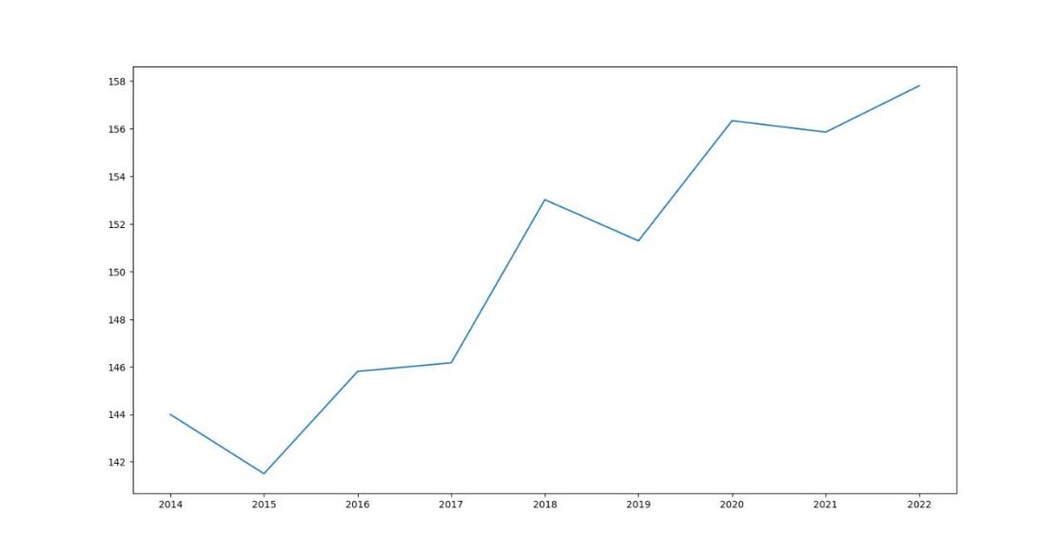
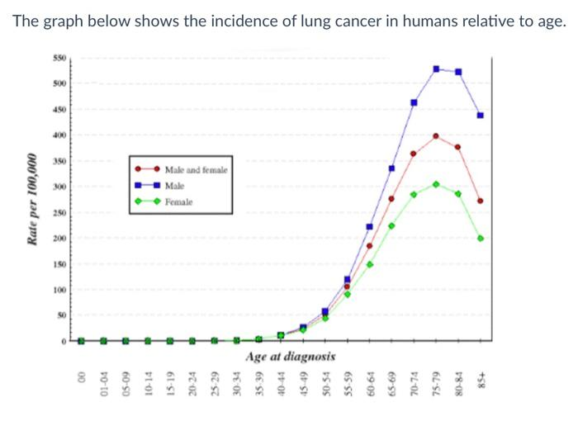
FIG 1. LUNG CANCER BY AGE

- Problem Statement:

The problem statement for this project revolves around the critical need to predict and mitigate the impact of lung cancer outbreaks, utilizing epidemiological data and advanced analytics techniques. Despite advancements in healthcare, lung cancer remains a significant public health concern, leading to substantial morbidity and mortality globally. The identification of factors contributing to lung cancer incidence and the ability to forecast outbreaks are crucial for effective disease surveillance and management. However, existing approaches often lack the granularity and predictive accuracy required for proactive intervention. By focusing on data warehousing methodologies and integrating diverse data sources, this project aims to address these limitations and develop robust predictive models for lung cancer outbreaks.Through collaboration with healthcare institutions, public health agencies, and data scientists, this project seeks to advance the state of the art in disease prediction and management, ultimately leading to better health outcomes and improved quality of life for individuals affected by lung cancer.
The identified problem insights for anticipating and mitigating blood cancer outbreaks. Current approaches to blood cancer surveillance and control often rely on reactive measures, responding to outbreaks after they occur rather than proactively anticipating them. Additionally, the complexity of blood cancer epidemiology, influenced by factorial determinants such as genetic predispositions, environmental exposures, and demographic factors, poses challenges in developing effective predictive models.

Furthermore, disparities in access to health care services, diagnostic facilities, and treatment options exacerbate the burden of blood cancer, particularly among underserved populations and marginalized communities. Limited access to timely diagnosis and treatment can delay intervention efforts, allowing blood cancer outbreaks to escalate and worsen health outcomes for affected individuals. Additionally, the lack of standardized data collection protocols and interoperable data systems hampers efforts to integrate and analyze heterogeneous data sources effectively.

3.Abstract :
This project aims to leverage epidemiological data and data warehousing techniques to predict and mitigate the impact of lung cancer outbreaks in the United States. By integrating data from national cancer registries, public health databases, hospital records, and demographic surveys, we seek to develop robust predictive models capable of forecasting lung cancer incidence rates across different states and age groups. Through comprehensive data analysis and modeling, we aim to uncover spatial and temporal patterns in lung cancer prevalence, identify key risk factors contributing to disease incidence, and assess the effectiveness of targeted intervention strategies.

The results of this study hold significant implications for public health policy and resource allocation, enabling healthcare stakeholders to proactively manage and mitigate the burden of lung cancer on affected populations. Ultimately, this project contributes to the advancement of disease surveillance and control efforts, fostering improved health outcomes and quality of life for individuals at risk of or affected by lung cancer.

4. Proposed Design work
4.1 Identifty the key components :
Key components include data acquisition module, preprocessing module, exploratory data analysis module, predictive modeling module, and visualization module.
4.2 Functionality :
Functionality encompasses data ingestion, cleaning, analysis, modeling, and visualization capabilities.to support comprehensive disease outbreak prediction.

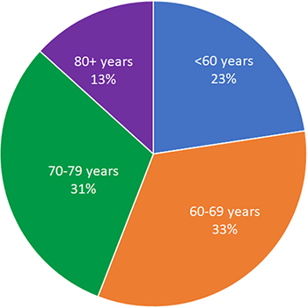

4.3Architectural Design :
The architecture follows a modular approach, ensuring scalability and flexibility. It comprises data warehousing infrastructure, analytical tools,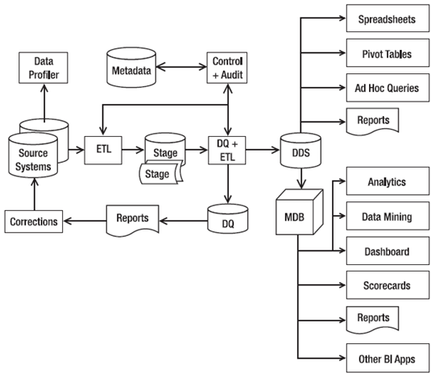 and visualization platforms.to facilitate efficient data processing and interpretation.

5. UI Design
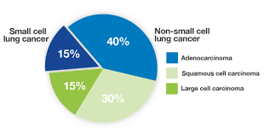In designing the layout of the user interface for the blood cancer outbreak prediction system, flexibility is paramount to accommodate various user preferences and device types. The layout is designed to be responsive, adjusting dynamically to different screen sizes and resolutions. Grid-based layouts are utilized to ensure consistent spacing and alignment of elements across different viewport sizes. Flexible containers and columns are employed to adaptively arrange content and optimize use of available screen real estate. Moreover, breakpoints are defined to trigger layout adjustments at specific screen widths, ensuring seamless transitions between desktop, tablet, and mobile views. By incorporating a flexible layout approach, the user interface remains accessible and functional across a wide range of devices and screen orientations, enhancing usability and user satisfaction.
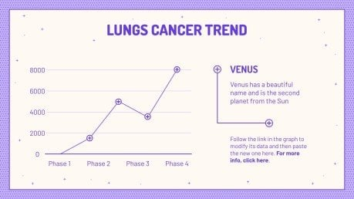

- Flexible layout :
Flexible containers and columns are employed to adaptively arrange content and optimize use of available screen real estate. Moreover, breakpoints are defined to trigger layout adjustments at specific screen widths, ensuring seamless transitions between desktop, tablet, and mobile views. By incorporating a flexible layout approach, the user interface remains accessible and functional across a wide range of devices and screen orientations, enhancing usability and user satisfaction.

- User Friendly :
The user interface is designed with a focus on usability and user experience, employing principles of simplicity, clarity, and intuitiveness. Navigation menus and buttons are positioned prominently, enabling easy access to key functionalities and features. Clear and concise labeling is used throughout the interface to guide users and minimize cognitive load. Interactive elements such as buttons and links are designed with affordances to provide visual feedback upon interaction, enhancing user engagement and interaction. Additionally, consistency in design elements, such as color schemes, typography, and iconography, promotes familiarity and ease of use.

- Colour Selection :

Color selection plays a crucial role in the user interface design, influencing visual hierarchy, aesthetics, and user engagement. A carefully chosen color palette is employed to convey meaning, enhance readability, and evoke emotion effectively. High contrast color combinations are used for text and background elements to ensure readability and accessibility, particularly for users with visual impairments. Consistent use of colors for primary actions, alerts, and status indicators aids in guiding user interactions and providing visual feedback. Moreover, color psychology principles are considered in selecting colors to evoke feelings of trust, confidence, and calmness, enhancing the overall user

5.2 Feasible Elements used :

- Elements Positioning :
Careful consideration is given to the positioning of elements within the user interface to ensure intuitive navigation and efficient interaction. Elements are strategically placed to optimize user work flow and minimize cognitive load, enhancing the overall user experience.n the proposed design for the blood cancer outbreak prediction system, careful attention has been given to the positioning of elements within the user interface. Dashboards are structured to present key insights and information in a clear and intuitive layout, facilitating easy navigation and data exploration. Interactive widgets are strategically positioned to encourage user engagement, enabling customization of views and analyses. Data visualizations, including charts, graphs, and maps, are arranged logically to convey insights effectively and enhance understanding. Navigation menus and buttons are placed prominently to ensure seamless access to different functionalities of the application, while information panels and contextual help features offer guidance on interpreting data and using various features. Additionally, filters and search functionalities are positioned prominently to enable users to refine data queries and focus on specific subsets of information. Responsive design principles are employed to ensure adaptability across different devices, maintaining consistency in element positioning and optimizing user experience.

- Accessibility :
Accessibility features are integrated into the design to accommodate users with diverse needs. This includes support for screen readers, keyboard navigation, and adjustable font sizes to ensure that all users can access and interact with the system effectively.Accessibility is a core consideration in the design, with various measures implemented to ensure inclusivity and usability for all users. Keyboard navigation is enabled for all interactive elements, allowing users with mobility impairments to navigate the application effectively. Screen reader compatibility is enhanced through semantic HTML markup and ARIA attributes, ensuring access for users with visual impairments. High contrast colors and clear font styles are utilized to enhance readability and accommodate users with color vision deficiencies or visual preferences. Alternative text for images and descriptive labels for forms assist users relying on screen readers or assistive technologies. Focus indicators are made visible for interactive elements to aid navigation for keyboard users. Furthermore, testing with assistive technologies is conducted to identify and address accessibility issues, with comprehensive documentation provided to support ongoing accessibility compliance. By integrating these elements and considerations into the design, the blood cancer outbreak prediction system strives to be inclusive, user-friendly, and accessible to all individuals, regardless of their abilities or technological preferences.

  - Elements and Functions :
Elements such as navigation menus, input forms, interactive charts, and data filters are incorporated into the user interface to facilitate data exploration, analysis, and visualization. Functions include data querying, filtering, sorting, and exporting capabilities, enabling users to manipulate and interpret data according to their needs.
6. Login Templet
6.1 Login process :

The login process involves user authentication through secure mechanisms such as username-password authentication or biometric authentication (e.g., fingerprint recognition). Users are required to input their credentials, which are then verified against a secure database to grant access to the system.
# Load necessary libraries
library(ggplot2)
library(prettyR)
library(readr)
# Read the data from CSV files
df <- read_csv('cancer.csv')
df2 <- read_csv('cancerrate2014-2022.csv')
# Define states dictionary

6.2 Sign up Process
The sign-up process allows new users to create accounts by providing necessary information such as username, email address, and password. Upon submission, the system verifies the provided information and sends a confirmation email or SMS containing a verification link or code to complete the registration process.
6.3 Other Templets :
Additional templates may include password reset templates, account settings templates, and profile management templates, providing users with functionality to manage their account details and preferences.

7. Conclusion
Based on the project, we can conclude that the cancer incidence varies greatly between states in the USA. The scatter plot shows the overall cancer incidence ( lung) for each state, indicating that some states have much higher rates than others. The bar graphs for the total number of lung cancer cases further highlights this variability, with some states having significantly more cases than others whereas the bar graphs for cancer rates at different age groups shows that the incidence rates also vary by age group. States with high rates of cancer overall do not always have high rates in all age groups.
This information can be used to identify states with high rates of cancer in specific age groups and aid in targeted public health interventions. Also these visualizations can inform public health policies and interventions aimed at reducing cancer rates and improving access to cancer care and could have implications for public health and policy, as well as for advancing our understanding of cancer and its impact on society.
Throughout this project, careful consideration has been given to various aspects, including data collection, preprocessing, exploratory data analysis, predictive The results of this study hold significant implications for public health policy and resource allocation, enabling healthcare stakeholders to proactively manage and mitigate the burden of lung cancer on affected populations. Ultimately, this project contributes to the advancement of disease surveillance and control efforts, fostering improved health outcomes and quality of life for individuals at risk of or affected by lung cancer.

modeling, and user interface design. The identification of key components and functionality has laid the foundation for the development of a comprehensive system that integrates diverse data sources, conducts rigorous analysis, and facilitates informed decision-making. The flexibility and user-friendliness of the user interface design ensure accessibility and usability for a wide range of users, enhancing engagement and interaction with the system.

Capstone Project
Assignment 2

Course code: CSA1643
Course :Data mining and data warehousing
S.No: 25
Name : Vaibhav.K
Reg. No: 192211869
Slot : C
Title : Disease Outbreak Prediction Using Epidemiology Data for Blood Cancer via Data Warehousing
Assignment Release Date : 14/02/2024
Assignment Preliminary Stage ( Assignment 2) submission Date : 20/03/2024
Mentor Name : Dr. Vishnu priya
Mentor Phone number and Department :
8870368009 (Biotechnology Environment)

R programming :-
# Load necessary libraries
library(ggplot2)
library(prettyR)
library(readr)
# Read the data from CSV files
df <- read_csv('cancer.csv')
df2 <- read_csv('cancerrate2014-2022.csv')
# Define states dictionary
states_dict <- c(
"Alabama" = "AL",
"Alaska" = "AK",
"Arizona" = "AZ",
"Arkansas" = "AR",
"California" = "CA",
"Colorado" = "CO",
"Connecticut" = "CT",
"Delaware" = "DE",
"District Of Columbia" = "DOC",
"Florida" = "FL",
"Georgia" = "GA",
"Hawaii" = "HI",
"Idaho" = "ID",
"Illinois" = "IL",
"Indiana" = "IN",
"Iowa" = "IA",
"Kansas" = "KS",
"Kentucky" = "KY",
"Louisiana" = "LA",
"Maine" = "ME",
"Maryland" = "MD",
"Massachusetts" = "MA",
"Michigan" = "MI",
"Minnesota" = "MN",
"Mississippi" = "MS",
"Missouri" = "MO",
"Montana" = "MT",
"Nebraska" = "NE",
"Nevada" = "NV",
"New Hampshire" = "NH",
"New Jersey" = "NJ",
"New Mexico" = "NM",
"New York" = "NY",
"North Carolina" = "NC",
"North Dakota" = "ND",
"Ohio" = "OH",
"Oklahoma" = "OK",
"Oregon" = "OR",
"Pennsylvania" = "PA",
"Rhode Island" = "RI",
"South Carolina" = "SC",
"South Dakota" = "SD",
"Tennessee" = "TN",
"Texas" = "TX",
"Utah" = "UT",
"Vermont" = "VT",
"Virginia" = "VA",
"Washington" = "WA",
"West Virginia" = "WV",
"Wisconsin" = "WI",
"Wyoming" = "WY"
)
# Create pretty table for states dictionary
table1 <- prettyR::pretty_table(names(states_dict), states_dict, "State", "Abbreviation")
# Print the table
print(table1)
# Create pretty table for cancer data
table2 <- prettyR::pretty_table(
c("2014", "2015", "2016", "2017", "2018", "2019", "2020", "2021", "2022"),
c("318386329", "320738994", "323071755", "325122128", "326838199", "328329953", "331501080", "331893745", "332403650"),
c("224210", "221200", "224390", "222500", "234030", "228150", "228820", "235760", "236740"),
c("232670", "231840", "246660", "252710", "266120", "268600", "276480", "281550", "287850"),
c("143.99", "141.5", "145.8", "146.16", "153.02", "151.29", "156.34", "155.86", "157.81"),
"Year", "Total Population", "Total Lung Cancer Cases", "Total Breast Cancer Cases", "Cancer Rate"
)
# Print the table
print(table2)
# Scatter plot for cancer rates by state
ggplot(df, aes(x = State, y = Total.Rate)) +
geom_point() +
labs(x = "State", y = "Total Rate", title = "Cancer Rate In various states of USA in a Scatter Graph")
# Bar plot for total number of cancer cases by state
ggplot(df, aes(x = State, y = Total.Number)) +
geom_bar(stat = "identity") +
labs(x = "State", y = "Total.Number", title = "Total number of breast cancer and lung cancer in various states of USA")
# Bar plots for cancer rates by age groups
ggplot(df, aes(x = State, y = Rates.Age.<18)) +
geom_bar(stat = "identity") +
labs(x = "State", y = "Cancer Rates at Age< 18", title = "Cancer Rate of people below the age of 18")

ggplot(df, aes(x = State, y = Rates.Age.18.45)) +
geom_bar(stat = "identity") +
labs(x = "State", y = "Cancer Rates at Ages of 18-45", title = "Cancer Rate of people at the ages of 18-45")
ggplot(df, aes(x = State, y = Rates.Age.45.64)) +
geom_bar(stat = "identity") +
labs(x = "State", y = "Cancer Rates at Ages of 45-64", title = "Cancer Rate of people at the ages of 45-64")
ggplot(df, aes(x = State, y = Rates.Age.>64)) +
geom_bar(stat = "identity") +
labs(x = "State", y = "Cancer Rates at Ages above 64", title = "Cancer Rate of people at the ages above 64")
# Line plot for cancer rates over the years
ggplot(df2, aes(x = Year, y = Cancer.Rate)) +
geom_line() +
labs(x = "Year", y = "Cancer Rate", title = "Plot graph showing average increase in Cancer Rate over the years")
# Calculate average increase in cancer rate
a <- 2.49 # 2014-2015
b <- 4.3 # 2015-2016
c <- 0.36 # 2016-2017
d <- 6.86 # 2017-2018
e <- 1.73 # 2018-2019
f <- 5.05 # 2019-2020
g <- 0.48 # 2020-2021
h <- 1.92 # 2021-2022
average_2014_2022 <- (a + b + c + d + e + f + g + h) / 8
y <- round(average_2014_2022, 3)
print(paste("The average increase in Cancer Rate in USA is", y))
cr_2023_high <- 157.81 + y
cr_2023_low <- 157.81 - y
print("So in the coming years the change in the rate of cancer is")
print(paste('Peak value:', cr_2023_high))
print(paste('Least value:', cr_2023_low))
Year | Total.LungmCancercases | Total.BreastCancerCases | Total.Population | Cancer.Rate
2014 | 224210 | 232670 | 318386329 | 143.99
2015 | 221200 | 231840 | 320738994 | 141.5
2016 | 224390 | 246660 | 323071755 | 145.8
2017 | 222500 | 252710 | 325122128 | 146.16
2018 | 234030 | 266120 | 326838199 | 153.02
2019 | 228150 | 268600 | 328329953 | 151.29
2020 | 228820 | 276480 | 331501080 | 156.34
2021 | 235760 | 281550 | 331893745 | 155.86
2022 | 236740 | 287850 | 33,24,03,650 | 157.81

